Advance Excel Assignment – 7

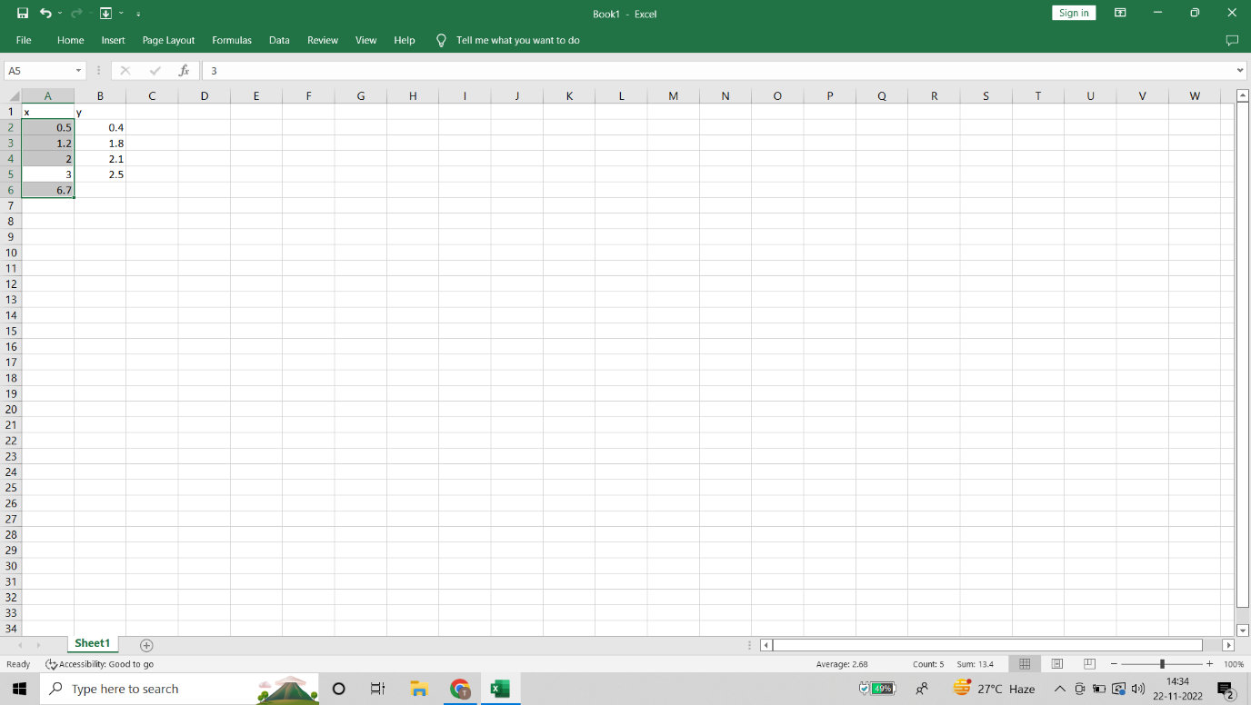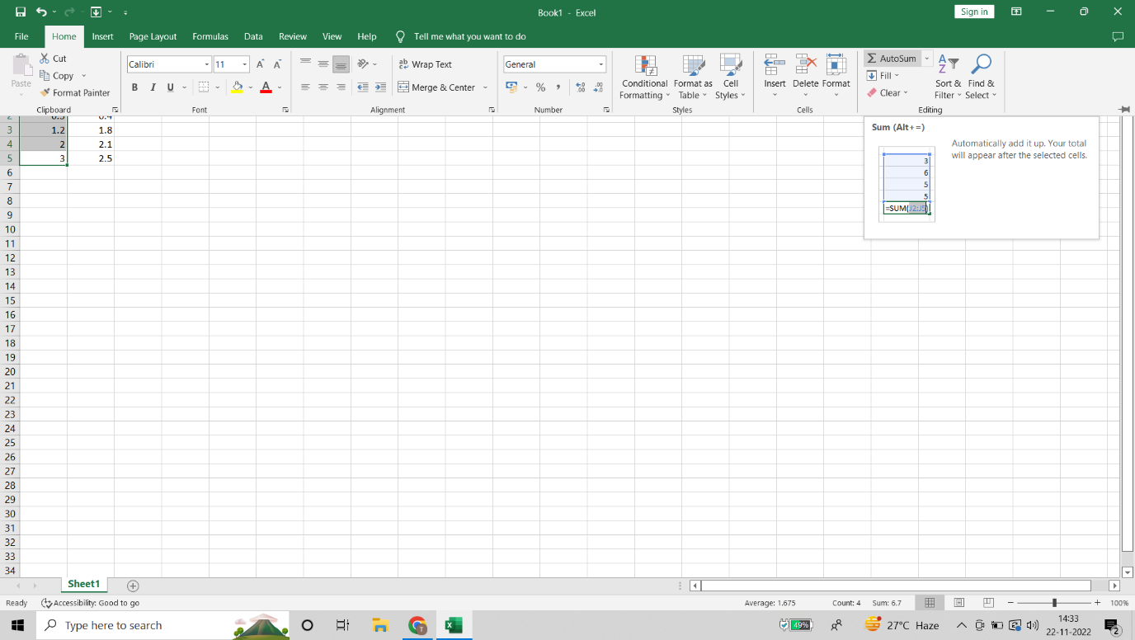



**Select one or more cells**

1. Click on a cell to select it. Or use the keyboard to navigate to it and select it.
2. To select a range, select a cell, then with the left mouse button pressed, drag over the other cells.

Or use the Shift + arrow keys to select the range.

1. To select non-adjacent cells and cell ranges, hold Ctrl and select the cells.

**Select one or more rows and columns**

1. Select the letter at the top to select the entire column. Or click on any cell in the column and then press Ctrl + Space.
2. Select the row number to select the entire row. Or click on any cell in the row and then press Shift + Space.
3. To select non-adjacent rows or columns, hold Ctrl and select the row or column numbers.

**Select table, list or worksheet**

1. To select a list or table, select a cell in the list or table and press Ctrl + A.
2. To select the entire worksheet, click the **Select All** button at the top left corner.
3. AutoFit is a feature in Excel that allows you to quickly [adjust the row height](https://trumpexcel.com/change-row-height-excel/) or column width to fit the text completely (so that there is no spilling over to other cells).

Also, AutoFit means that you don’t have to manually specify the column width or row height (or manually drag and adjust the column width). It’s Auto- i.e., it will figure out itself how much it should expand/contract to fit the current cell content

1. To add row and column

You can add a row above or below the cursor position.

1. Click where you want in your table to add a row or column and then click the **Layout** tab (this is the tab next to the **Table Design**tab on the ribbon).
2. To add rows, click **Insert Above** or **Insert Below** and to add columns, click **Insert Left** or **Insert Right**.

You can add a row above or below the cursor position.

1. Click where you want in your table to add a row or column and then click the **Layout** tab (this is the tab next to the **Table Design**tab on the ribbon).
2. To add rows, click **Insert Above** or **Insert Below** and to add columns, click **Insert Left** or **Insert Right**.
3. Under Visibility, click Hide & Unhide, and then click Unhide Rows or Unhide Columns.

### **Hide columns**

1. Select one or more columns, and then press Ctrl to select additional columns that aren't adjacent.
2. Right-click the selected columns, and then select **Hide**.

### **Unhide columns**

1. Select the adjacent columns for the hidden columns.
2. Right-click the selected columns, and then select **Unhide**.
3. 